Question 2: Security Engineering & Threat-Based Controls

Introduction
Security is best when it is built into the Software Development Life Cycle (SDLC) from the beginning and not added on or just before release with penetration testing. Modern software systems are vulnerable to threats in authentication, access control, software supply chains, data handling and operational visibility. Security evaluated at the end of development means that vulnerabilities are already built into the system architecture, codebase and deployment processes (OWASP, 2025).
Security engineering therefore is about identifying credible threats, translating those threats into security requirements, implementing appropriate controls and collecting evidence that demonstrates whether those controls are effective. This method establishes traceability from risk to verification instead of relying on isolated security scans or one-time assessments (NIST, 2026).

2.1 Threat modelling and its purpose
Threat modelling is a systematic approach to identify how an attack could be carried out on a system, which assets need to be protected and what controls can be implemented to reduce the risk. Threat modelling is a repeatable process to analyse a system from an adversarial perspective to identify threats and define appropriate responses before implementation decisions are final (OWASP, 2025).
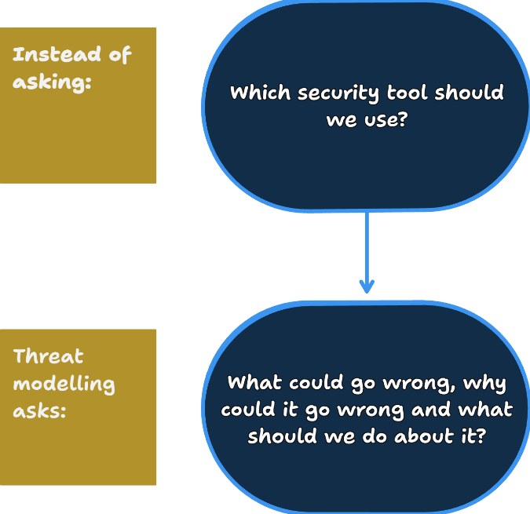

2.1.1 STRIDE Threat Modelling
One recognised threat modelling approach is Microsoft’s STRIDE framework (Microsoft, 2022).
STRIDE categorises threats into six major groups:
STRIDE Category | Security Concern
S - Spoofing | Impersonating another user or system
T - Tampering | Unauthorised modification
R - Repudiation | Denying actions because evidence is lacking
I – Information Disclosure | Exposure of information to unauthorised parties
D – Denial of Service | Preventing legitimate access to services
E – Elevation of Privilege | Gaining higher permissions than intended

Example STRIDE reasoning:
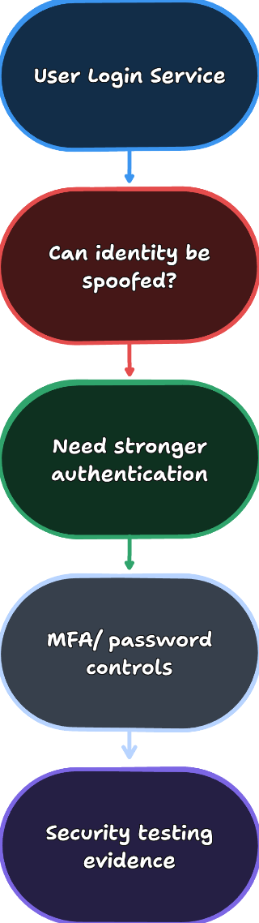
The value of STRIDE is not memorising threat categories but using them to systematically identify security concerns during design before software is deployed (Microsoft, 2022).

2.2 Threat to Control Traceability Table
The following table demonstrates how threats can be traced to security requirements, controls and verification evidence.
Threat | Security Requirement | Possible Engineering Control | Verification Evidence | Residual Risk
Attacker steals a password and impersonates a legitimate user (Spoofing) | Ensure only legitimate users can access accounts | Strong password policy, MFA, secure session management | Authentication testing, MFA verification, penetration testing, access logs | User devices may still be compromised or credentials phished
Authenticated user accesses another user’s records (Elevation of Privilege / Information disclosure) | Restrict users to authorised resources only | Role bases access control, server-side authorisation checks, least privilege principles | Authorisation tests, security reviews, access control testing | Misconfigured roles or business logic flaws may still exist
API keys or database credentials exposed in source code repositories | Protect sensitive secrets from disclosure | Secrets manager, secret rotation, least privilege access | Secret scanning tools, configuration reviews, audit logs | Secrets could still be leaked through compromised authorised accounts
Application depends on a package with a known vulnerability | Reduce exposure to supply-chain vulnerabilities | Dependency scanning, Software Bill of Materials, patch management process | SCA scans, dependency reports, CI security checks | Newly discovered vulnerabilities may appear after deployment
Malicious user submits harmful input to exploit the system | Validate and safely handle all user input | Input validation, parameterised queries, output encoding, secure error handling | Static analysis, security testing, manual code review | Unknown attack techniques may bypass incomplete validation
User performs an action but later denies it (Repudiation) | Maintain accountability and traceability | Centralised logging, audit trails, timestamped records | Log verification, audit reviews, incident investigations | Logs could become incomplete if logging coverage is insufficient

2.3 Four key security concern areas

2.3.1 Authentication
Authentication ensures that a user is who they say they are. Credential theft is a common threat via brute force attacks, phishing or credential stuffing. The security goal is to guarantee that only authorised users have access to protected functionality.
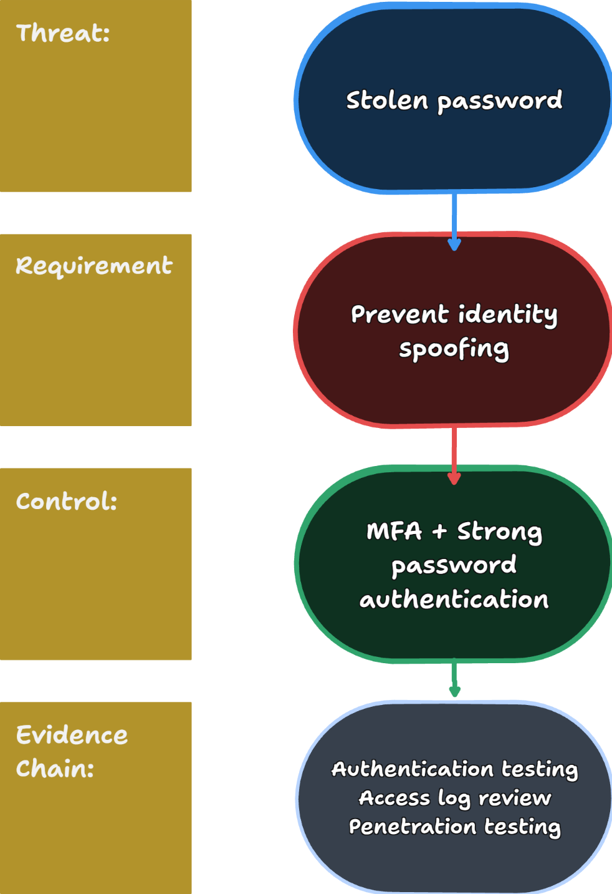
OWASP recommendations include strong authentication practices with MFA because passwords are often compromised (OWASP, Authentication Cheat Sheet, 2025).

2.3.2 Authorisation and Access Control
Authentication determines who the user is while authorisation determines what they are able and allowed to do. A major risk in web applications is an authenticated user accessing data belonging to other users.
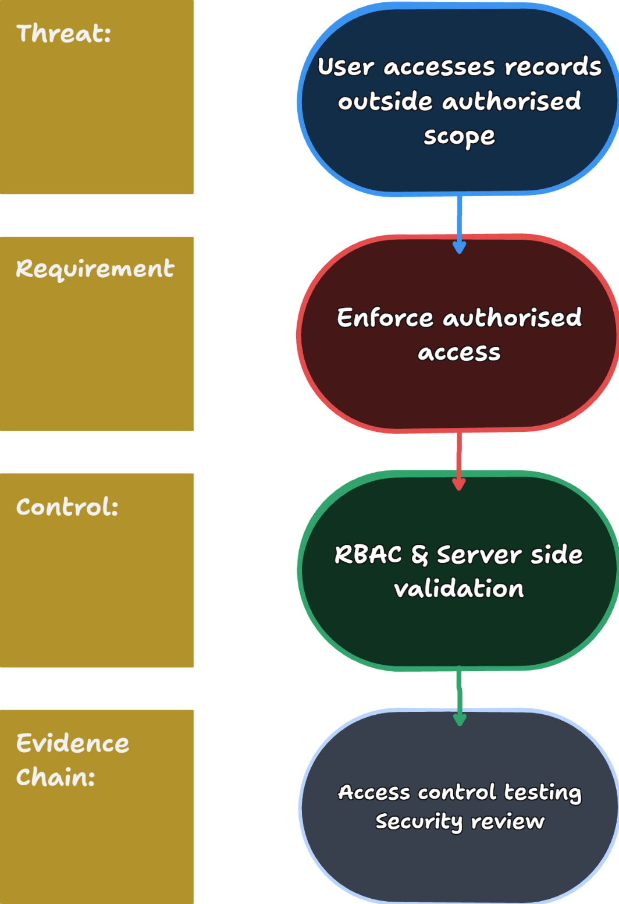
Broken access control is one of the most prevalent and serious web application security risks, as failures can leak sensitive information even when authentication is functioning correctly (OWASP, Authorization Cheat Sheet, 2025).

2.3.3 Secrets and Configuration management
Credentials, API keys, certificates and common strings are all a part of modern applications. Hardcoded values in source code pose major disclosure risk as repository history, backups and forks may still expose credentials even after they have been removed (OWASP, Secrets Management Cheat Sheet, 2025).
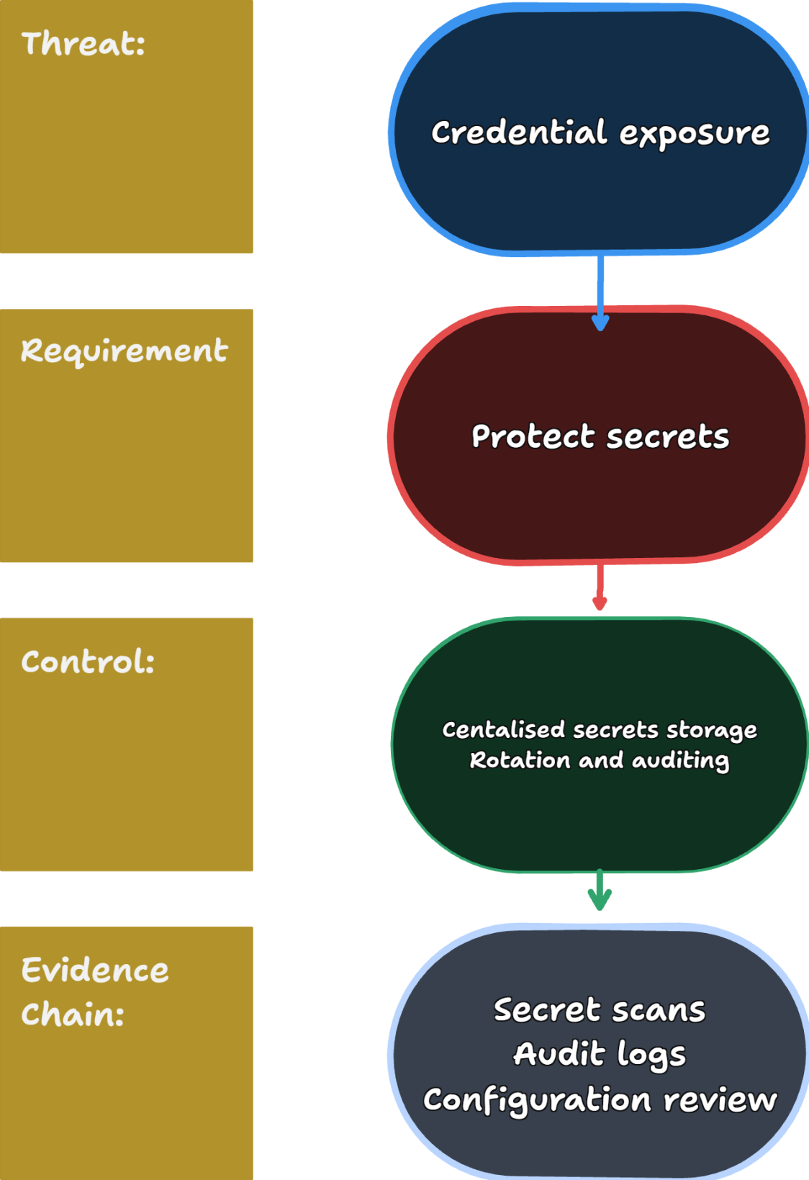
Instead of storing secrets directly in application code, OWASP recommends centralising, rotating and auditing secrets (OWASP, Secrets Management Cheat Sheet, 2025).

2.3.4 Dependency Vulnerabilities
Modern software is built on the backs of hundreds of third-party libraries and packages. Even if the application code is secure, security weaknesses may be introduced in a dependency.
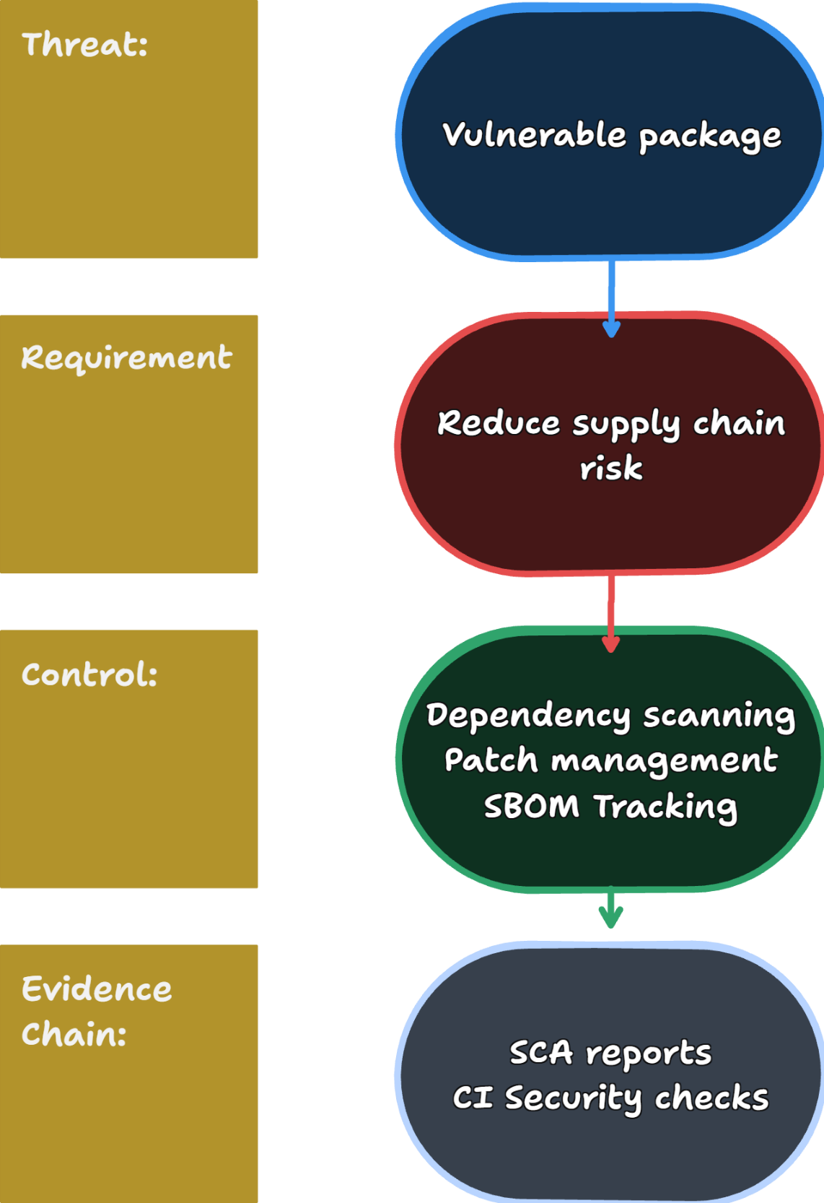
Software supply chain vulnerabilities have become a major source of compromise. NIST’s Secure Software Development Framework (SSDF) recommends continuous identification and management of risks from third-party components (NIST, 2026).

2.4 Secure Design, Secure Coding and Security Checks
Security controls are most effective when they work together rather than serving as replacements for one another.
Security Activity | Purpose
Secure Design | Prevents the creation of vulnerabilities in system architecture
Secure Coding | Reduces errors in implementation during development
Security Checks and Scanning | Pinpoints weaknesses which may have been introduced despite design and coding efforts

A useful way to view this relationship is:
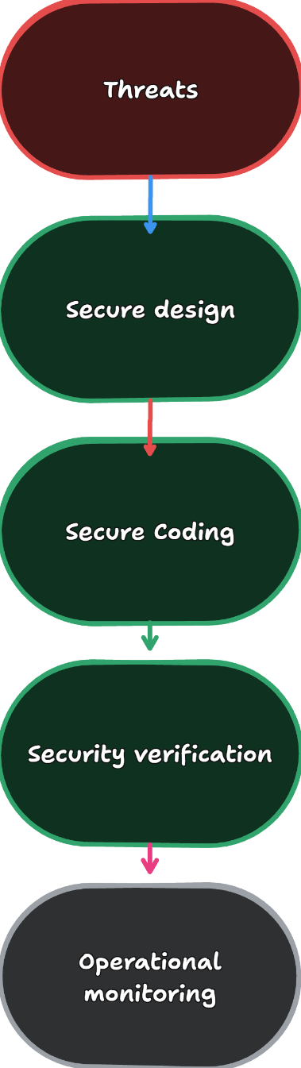
A design that is insecure can still be implemented securely. Well written code can still be dependent on vulnerable dependencies. Security scanners can find out some problems but cannot fully check architectural decisions, business logic or organisational practices. Therefore, these activities complement each other and are not substitutes (NIST, 2026) (OWASP, 2025).

2.5 Limitations of Automated Security Tools and AI Recommendations
Automated security tools provide valuable assistance but should not be treated as proof that a system is secure.

Limitation 1: Tools only detect known patterns
Static analysis tools, dependency scanners and vulnerability scanners typically identify known classes of weaknesses that may fail to detect:
- Business logic flaws
- Incorrect authorisation decisions
- Abuse of legitimate functionality
- Context specific security weaknesses
A scanner may therefore report no critical findings while important vulnerabilities remain undetected (OWASP, 2025) (OWASP, Authorization Cheat Sheet, 2025).

Limitation 2: False Positives and False Negatives
Security tools can generate false positives, meaning they report problems that are not actual vulnerabilities. They can also generate false negatives which means that real vulnerabilities are not detected and reported.
Further human analysis is needed to determine if findings are valid and if more controls are needed (NIST, 2026).

Limitation 3: AI recommendations may lack context
Security advice generated by standard AI may be helpful to identify potential controls, explain concepts or suggest secure coding practices. But AI solutions can recommend the wrong controls, skip key threats, misinterpret architectural details or provide unverified or outdated guidance. Any AI generated recommendation therefore requires independent verification against authoritative security sources and the actual system requirements.

References
Microsoft. (2022, 08 25). Microsoft Threat Modeling Tool threats. From Microsoft: https://learn.microsoft.com/en-us/azure/security/develop/threat-modeling-tool-threats
NIST. (2026, 04 13). Secure Software Development Framework SSDF. From NIST: https://csrc.nist.gov/Projects/ssdf
OWASP. (2025). Authentication Cheat Sheet. From OWASP: https://cheatsheetseries.owasp.org/cheatsheets/Authentication_Cheat_Sheet.html
OWASP. (2025). Authorization Cheat Sheet. From OWASP: https://cheatsheetseries.owasp.org/cheatsheets/Authorization_Cheat_Sheet.html
OWASP. (2025). Dependency Graph & SBOM Best Practices Cheat Sheet. From OWASP: https://cheatsheetseries.owasp.org/cheatsheets/Dependency_Graph_SBOM_Cheat_Sheet.html
OWASP. (2025). OWASP Cheat Sheet Series. From OWASP: https://owasp.org/projects/cheat-sheet-series
OWASP. (2025). Secrets Management Cheat Sheet. From OWASP: https://cheatsheetseries.owasp.org/cheatsheets/Secrets_Management_Cheat_Sheet.html
OWASP. (2025). Threat Modeling Cheat Sheet. From OWASP: https://cheatsheetseries.owasp.org/cheatsheets/Threat_Modeling_Cheat_Sheet.html

